 

**Fundamentals of Databases (CBIO204)**

**clinic_management_system**

**Project: 03**

**Supervision: Dr Muhammed elsayeh**

|  |  |
| --- | --- |
| Student Name | ID |
| Nada essam saber | 231001261 |
| Jana sherif elsisy | 231002223 |
| Youssef ahmed elshorbagy | 231001220 |

ERD photo

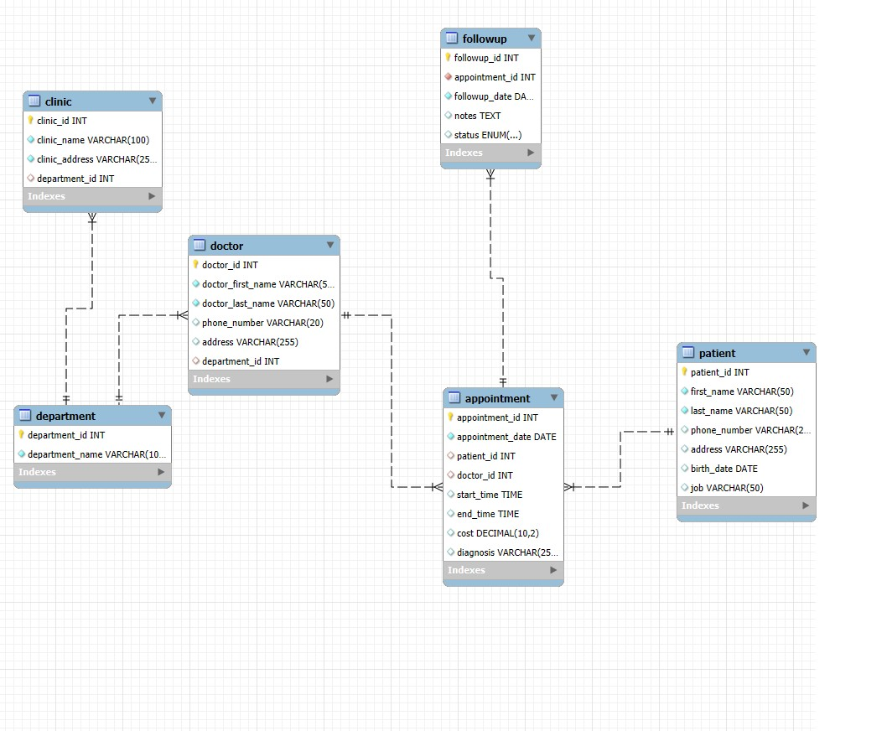

**2. ER Diagram with Cardinality & Participation We’ll have:**

Department ↔ Clinic → 1: N (One department has many clinics; each clinic belongs to one department) Department ↔ Doctor → 1: N (One department has many doctors; each doctor works in one department) Doctor ↔ Appointment → 1: N (One doctor has many appointments; each appointment has one doctor) Patient ↔ Appointment → 1: N (One patient can have many appointments; each appointment is for one patient) Appointment ↔ FollowUp → 1: N (One appointment can have many follow-ups; each follow-up is for one appointment)

**SQL Table Creation**

CREATE TABLE Department ( department_id INT PRIMARY KEY, department_name VARCHAR(100) NOT NULL );

CREATE TABLE Clinic ( clinic_id INT PRIMARY KEY, clinic_name VARCHAR(100) NOT NULL, clinic_address VARCHAR(255), department_id INT, FOREIGN KEY (department_id) REFERENCES Department(department_id) );

CREATE TABLE Doctor ( doctor_id INT PRIMARY KEY, doctor_name VARCHAR(100) NOT

NULL, doctor_phone VARCHAR(20), doctor_address VARCHAR(255), department_id INT, FOREIGN KEY (department_id) REFERENCES Department(department_id) );

CREATE TABLE Patient ( patient_id INT PRIMARY KEY, first_name VARCHAR(50), last_name VARCHAR(50), phone_number VARCHAR(20), address VARCHAR(255), birth_date DATE, job VARCHAR(100) );

CREATE TABLE Appointment ( appointment_id INT PRIMARY KEY, appointment_date DATE, patient_id INT, doctor_id INT, start_time TIME, end_time TIME, cost DECIMAL(10,2), status ENUM('scheduled','in progress','postponed'), diagnosis VARCHAR(255), FOREIGN KEY

(patient_id) REFERENCES Patient(patient_id), FOREIGN KEY (doctor_id) REFERENCES Doctor(doctor_id) );

CREATE TABLE FollowUp ( followup_id INT PRIMARY KEY, appointment_id INT, followup_date DATE, notes TEXT, FOREIGN KEY (appointment_id) REFERENCES Appointment(appointment_id) );

**Relational Schema for Medical Clinic Database:**

department ( department_id INT PRIMARY KEY, department_name

VARCHAR(100) NOT NULL )

patient ( patient_id INT PRIMARY KEY, first_name VARCHAR(50) NOT NULL, last_name VARCHAR(50) NOT NULL, phone_number VARCHAR(25) NOT NULL, address VARCHAR(255) NOT NULL, birth_date DATE NOT NULL, job VARCHAR(50)

)

doctor ( doctor_id INT PRIMARY KEY, doctor_first_name VARCHAR(50) NOT NULL, doctor_last_name VARCHAR(50) NOT NULL, phone_number VARCHAR(20) NOT NULL, address VARCHAR(255) NOT NULL, department_id INT NOT NULL,

FOREIGN KEY (department_id) REFERENCES department(department_id)

)

clinic ( clinic_id INT PRIMARY KEY, clinic_name VARCHAR(100) NOT NULL, clinic_address VARCHAR(255) NOT NULL, department_id INT NOT NULL,

FOREIGN KEY (department_id) REFERENCES department(department_id)

)

appointment (

appointment_id INT PRIMARY KEY, appointment_date DATE NOT NULL, patient_id INT NOT NULL, doctor_id INT NOT NULL, start_time TIME NOT NULL, end_time TIME NOT NULL, cost DECIMAL(10,2) NOT NULL, diagnosis VARCHAR(255),

FOREIGN KEY (patient_id) REFERENCES patient(patient_id),

FOREIGN KEY (doctor_id) REFERENCES doctor(doctor_id)

)

followup ( followup_id INT PRIMARY KEY, appointment_id INT NOT NULL, followup_date DATE NOT NULL, notes TEXT,

status ENUM('scheduled', 'pending', 'completed', 'cancelled') NOT NULL,

FOREIGN KEY (appointment_id) REFERENCES appointment(appointment_id)

)

1• List the name of patients who were diagnosed with fatty liver in the last year.

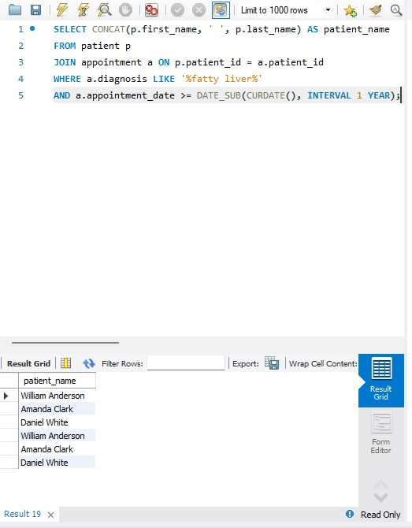

2• List the addresses of cardiology clinics.

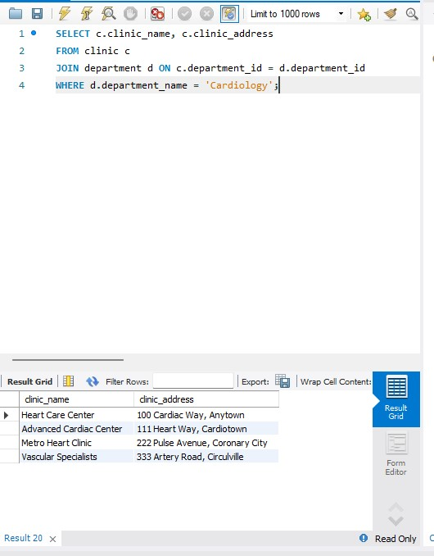

3• List the total money paid by a patient whose ID is 12527 in the last three years.

